**Lab 7**

**ITS265**

**Ghadir Alfadhl & Li Baio**

# Problem 1

Extract data columns from file Seattle2014.csv for rainfall and snowfall and get the average for the year for both. Also, extract out the first 31 days of data (January) and calculate the average rainfall and snowfall for January. Display the results.

Hint: The values in the file are in 1/10th of a mm. Convert to inches when displaying the average. Also, you will need to check for any null values or negative values and either convert to 0 or do not use in calculation.

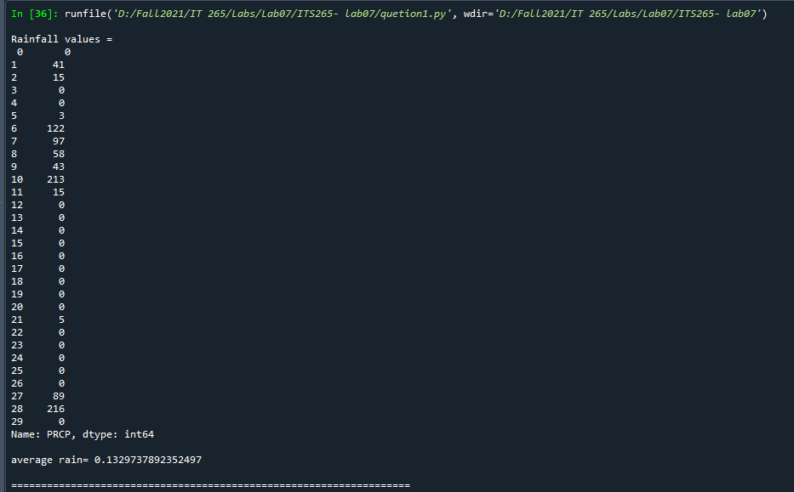

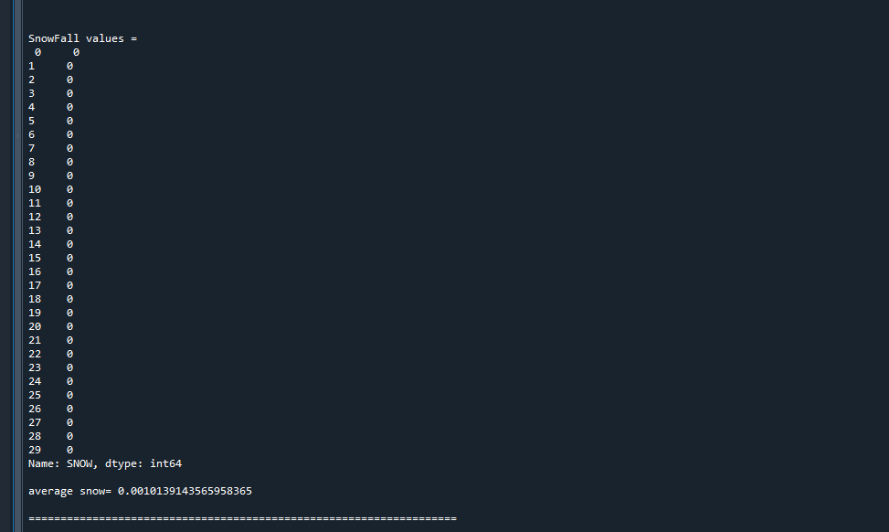

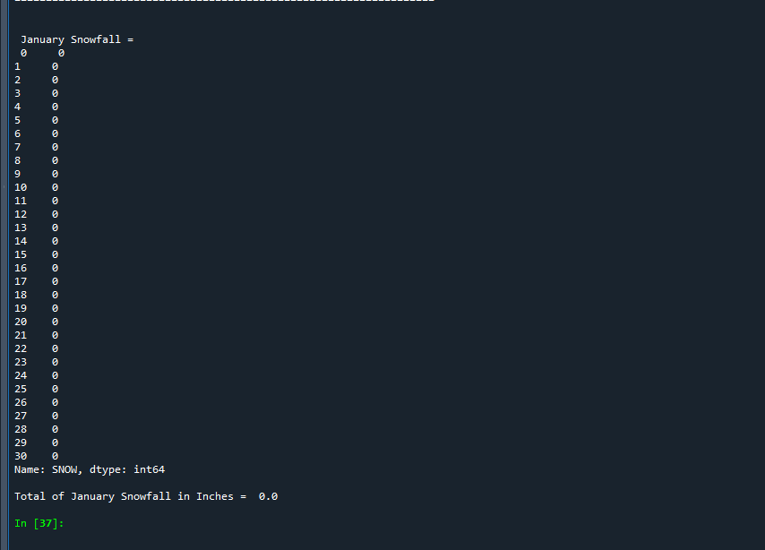

# Problem 2

Write a Python code using NumPy to find the Linear regression equation for given data (lab2data.txt). Use given equations to calculate b0 and b1of linear regression and coefficient of determinant (R2). Use useful NumPy functions, average and sum, for this question. Your code should display b1, b0, and R2 values.

Hint: Extract out from the datafile an x and y column. Then average the extracted columns by using the average function. Use the numpy sum function to calculate the sum for b1 and SStot and SSres.

Equations:

𝑦𝑝𝑟𝑒𝑑 = 𝑏0 +𝑏1 ∗𝑥

̅

𝑏1 = ∑𝑛𝑖=1(𝑥𝑖 −𝑥̅)2

𝑏0 = 𝑦̅ −𝑏1 ∗𝑥̅

2 = 1−𝑆𝑆𝑟𝑒𝑠

𝑅

𝑆𝑆𝑡𝑜𝑡

𝑤ℎ𝑒𝑟𝑒

𝑥̅ 𝑛 𝑛𝑖=1𝑥𝑖

𝑦̅ 𝑛 𝑛𝑖=1𝑦𝑖

𝑆𝑆𝑡𝑜𝑡 

2

𝑆𝑆𝑟𝑒𝑠 𝑦𝑝𝑟𝑒𝑑)

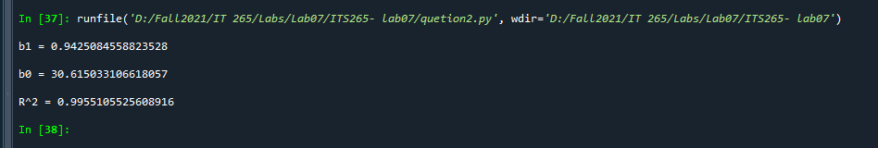

# Problem 3

Find the weighted grade of each student. Use matrix formulation to calculate it. Final grade should use matrix multiplication. Student grade files are given (lab2-hw.txt, lab2-test.txt, lab2quiz.txt, lab2-project.txt). Your code should display final grade for each student (A, B, C, D, E, and F).

Use following grading scale to calculate the final grade.

5 Homework 50 points each 30%

5 Quizzes 10 points each 10%

1. Project 100 points 20%
2. Tests 100 points each 40%

**Useful function**: astype, numpy colum_stack (use this to put together the averages of each grade category into array), numpy matmul (apply weights in array to the stacked grades).

**Hint**: each assessment has total score. You should covert them into 100 bases.

Final grade = G * W where G is grade matrix (rows are students’ grades and columns are assessments, 6x4) W is weight matrix (weight for each assessment, 4x1)

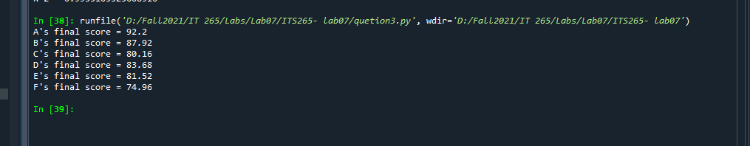

**Submission:** Use **Zip** to compress all code and submit to Brightspace. Use “**ITS265-Lab7*FirstnameLastname*.ZIP**” for the filename.